HIGHER EDUCATION (HE) PARTNER GUIDE TO

INTERNATIONAL
DUAL ACCREDITATION

Produced for: International HE Partners offering

CMI qualifications, Assessors, Deliverers and

Administrators.

Contents
History 4
Purpose 4
Introduction 5
International Centre Approval and Dual Accreditation 5
Stage 1 – Due Diligence and Quality Assurance (QA) checks 6
Stage 2 – Mapping 6
Mapping is sent to the Lead Moderator for sign off 7
HE Partner signposts the assessments to show CMI Learning outcomes 8
Mapping and assessment are internally verified by the HE Partner 8
Final CMI sign off and upload the mapping onto the HUB 8
Stage 3 – Further QA checks 9
Stage 4 – Provision of Quality Assurance system evidence 9
Stage 5 – Initial CMI Centre visit 9
Stage 6 – Approval notification and acknowledgement 9
Stage 7 - Yearly audit 9
Services available after approval 11
CMI Moderation after approval 12
Delivery and Assessment in languages other than English 14
Ensuring timely certification 14
Archive and training requirements 14
Suggested delivery approaches 14
Annual Roles and responsibilities of HE Partner staff 15
Programme Director 15
Checking relationship documentation 15
Co-ordinating yearly CMI centre visits 15
Checking Learner details on the CMI HUB 15
Checking internal records and annual moderation arrangements 15
Communication with tutors and checking staff records 16
Module Tutors 16
Demonstrating evidence 16
Coordinating authenticity 16
Meeting the moderator 16
Reconciling module changes with CMI mapping 16
CMI additional support 17
APPENDIX A: BASIC QA INDICATORS QUESTIONNAIRE WITH CONDITIONS OF CONFIDENCE 18
APPENDIX B: LEVEL 1-3 QA INDICATORS QUESTIONNAIRE 23
APPENDIX C: PREPARATION FOR QA VISIT - CHECKLIST 38
APPENDIX D: TEMPLATE FOR MODULE LEADERS’ SIGN OFF SHEETS 39
APPENDIX E: DISCLAIMER 40
APPENDIX F: LIST OF INFORMATION REQUIRED BY THE CMI SPECIALIST MAPPER 41
APPENDIX G: LIST OF INFORMATION REQUIRED BY THE MODERATOR 42
APPENDIX H: DIVERSITY AND EQUALITY DECLARATION 43
APPENDIX I SPECIAL CONSIDERATIONS DECLARATION 44
APPENDIX J REASONABLE ADJUSTMENT DECLARATION 45
APPENDIX K CONFLICTS OF INTEREST DECLARATION 47
APPENDIX L STUDENT DATA PROTECTION DECLARATION 50
APPENDIX M RECOGNITION OF PRIOR LEARNING DECLARATION 53
APPENDIX N MALPRACTICE AND MALADMINISTRATION DECLARATION 56
APPENDIX O COMPLAINTS AND APPEALS DECLARATION 60

PROCEDURE FOR GAINING

DUAL ACCREDITATION FOR NON-UK UNIVERSITIES

History

Version | Date approved | Actions from previous version | Owner
Version 1 | October 2016 | Produced in support of international pilot | EP
Version 2 | January 2017 | Amended following first international approval and internal audit. Changes include:  - Inclusion of flowcharts for mapping and moderation  - Changes relating to RQF e.g., inclusion of TQT and DLH  - Inclusion of a provisional international org chart | EP
Version 3 | Jan 2019 | Amended text following the introduction of new CMI level 5 syllabus; updates to associated documentation; change of organisational responsibilities; revision of dual accreditation policy at level 5; adoption of virtual centre visits; deletion of 10 questions from the approval questionnaires and rewording of others; amendments to the approval questionnaires to eliminate duplication and provide guidance.  The addition of declaration templates for equality and diversity, special considerations, reasonable adjustment, conflicts of interest, student data protection, recognition of prior learning, malpractice and maladministration. | EP

Purpose

The purpose of this procedure is to set out a clear and unambiguous approach on how Learners studying at non-UK Higher Education (HE) CMI Approved Centres can gain a CMI qualification alongside their HE programme. In order to successfully implement this system, the CMI procedure must be adhered to and approval sought from the CMI Quality Manager prior to the programme commencing.
A HE Partner, as an approved centre, can offer CMI qualifications by dual accreditation or as standalone qualifications.
Please note that unlike dual accreditation, direct delivery of CMI qualifications is likely to require additional local government approvals and this should be factored in to delivery plans. CMI will require formal notification of local approval requirements and will work with the university to achieve this.

Introduction
This document describes the dual accreditation approval process.
Provided that evidence of CMI Learning outcomes of a given unit or qualification can be found within existing HE Partner assignments, and that QA requirements can be met, the use of Dual Accreditation is acceptable for achieving CMI credits leading to an award, certificate or diploma. Evidence of learning must be valid, reliable and current.
A CMI qualification can be embedded within a University qualification, for example a BA Business Management plus CMI Level 5 Diploma in Management and Leadership (RQF). The Learner will then achieve a CMI qualification plus the HE Partner qualification. The main programme of study at the University needs to be a qualification such as an undergraduate or postgraduate degree which has been externally validated as having level-appropriate learning outcomes against the in-country HE qualifications framework.
If not already an approved centre, the University will need to apply to become an International CMI HE Partner in order to run these qualifications and register Learners.
The procedure for Centre Approval and Dual Accreditation is set out in subsequent sections of this document.

International Centre Approval and Dual Accreditation
It is possible to begin the process for Dual Accreditation mapping at the same time as applying to become an International HE Partner. See Figure 1. When applying for Dual Accreditation for an existing course please note that specific criteria need to be met to enable mapping against examination/test based OR Group work assessment methods due to CMI’s regulatory requirements which prescribe that all learning outcomes must be covered by the individual student. You are advised to discuss mapping opportunities with your CMI-designated Specialist Mapper for modules where examinations or group work are involved.
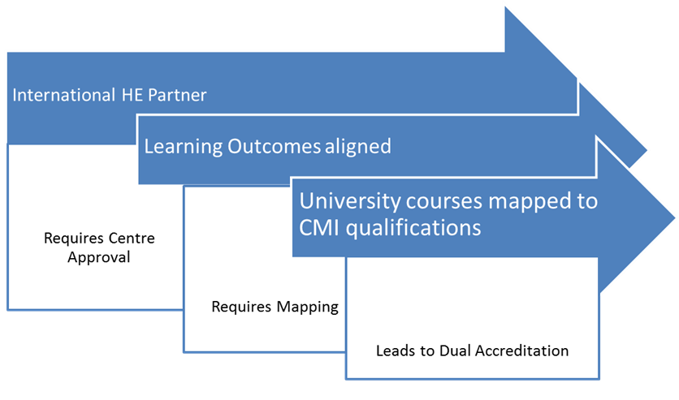
Figure 1 - showing an overview of how Centre Approval and Mapping lead to Dual Accreditation

The International Centre Approval and Mapping processes can be described in 7 stages. Figure 2 summarises the steps involved. Please note that Stage 5 may occur after Stage 6 due to travel logistics.
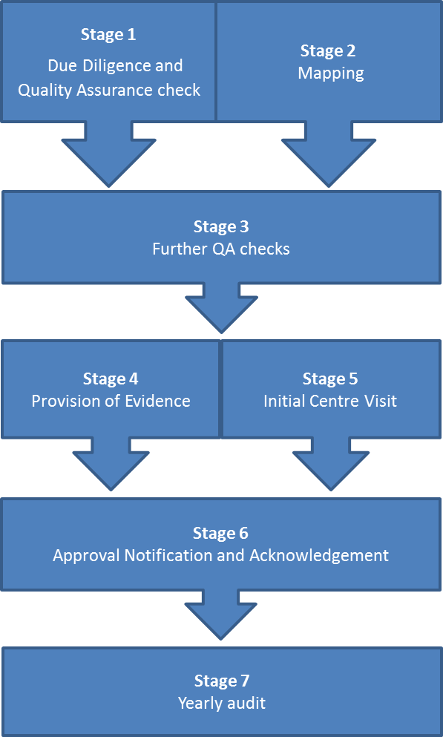
Figure 2 - illustrating the International Centre Approval and Dual Accreditation process

Stage 1 – Due Diligence and Quality Assurance (QA) checks
This stage involves the completion of a Due Diligence process by the CMI Higher Education Partnership team and simultaneously a check of basic Higher Education quality assurance indicators by the CMI Compliance team. The Due Diligence process will look at legal and financial viability of your centre. A check of basic quality assurance indicators will include Public, Regulatory and Statutory (PRS) issues as well as IT capability, language capability, acceptance of our conditions of confidence and willingness to sign a Regulatory Agreement.

Due Diligence is carried out by CMI Relationship Managers. The Quality Assurance (QA) check is carried out by the CMI International HE Quality Manager. The approval application is logged by the CMI approvals team for tracking purposes. On completion of this stage an introductory letter is sent to the potential Programme Director outlining next steps and key documents that need to be completed.

Stage 2 – Mapping

See Figure 3. – MAPPING FLOWCHART
The CMI Relationship Manager will need to initiate mapping on a centre’s behalf. Mapping is carried out by CMI-designated Mapping Specialist and requires the HE Partner to co-operate by providing detailed information on the programme, content of modules and assessment formats and assessment methods. Mapping is the process by which we deduce the degree of fit between CMI’s learning outcomes and those of the partner’s programme. A positive fit indicates a high likelihood that CMI Learning outcomes will be evidenced in the HE Partner’s assessments and therefore both institutions are likely to meet ‘Dual Accreditation’ requirements.
Undergraduate degree programmes are usually mapped to CMI Level 5. Postgraduate programmes are usually mapped to CMI Level 7 qualifications. At level 5, the results of a mapping exercise will conclude as a programme being designated as an award, certificate or diploma. For an award, learners must complete at least one module where CMI learning outcomes are met to a minimum of 40 TUT hours. For a certificate, learners must complete any combination of modules where CMI learning outcomes are met to a minimum of 121 TUT hours. For a diploma, learners must complete a combination of modules where CMI learning outcomes are met to a minimum of 370 TUT hours. TUT describes Total Unit Time estimated by the organisation for its modules.
Appendix F provides a summary of the information required by the CMI Mapping Specialist in order to complete the mapping activity.
This mapping is NOT a value judgement of the University programme. This mapping activity matches University learning outcomes and assessment methods for individual modules to CMI units. A University programme which maps to a CMI Award is not considered ‘worse’ that a programme which maps to a Diploma, it is only a measure of how many learning outcomes and modules can be aligned. In many cases, following discussion between the Specialist Mapper and module leaders, it is possible to amend the mapping outcome. When programmes are revalidated universities will often consider CMI units to enable a greater alignment and therefore university students may be eligible for further accreditation. The CMI assigned Specialist Mapper can work with the module leaders to assist in this process if so wished.
A CMI Mapping Specialist can complete all of the mapping at a cost of £500 + VAT per day. The mapping will be completed by CMI but the ownership and implementation of this lies with the HE Partner. On average this mapping will take 1-2 days to complete for ONE programme e.g. MBA. All programme specifications need to be sent electronically to CMI. The CMI HE Mapping Specialist will provide an estimate of the total time needed to map the programme (for example 2 days). Once agreed, an invoice will be raised and sent to the HE Partner. At the same time the mapping will start and will be completed within 20 working days.
Mapping will use a RAG system (RED, AMBER, GREEN) to show how well CMI content is covered in the main programme of study. Individual units will be mapped. If there are areas that are red it indicates there is currently no coverage of CMI learning outcomes. Amber indicates insufficient coverage or evidence to be verified in other areas. This can be reviewed with the CMI Mapping Specialist to show how any gaps will be covered. This could be done by additional workshops, viva / professional discussion, etc., or a tutor may identify other aspects of the programme that are already in place but not fully signposted in the documentation. Green indicates that CMI learning outcomes are likely to be met based on the evidence already provided.

Mapping is sent to the Lead Moderator for sign off
The mapping is then sent to the CMI HE Lead Moderator or Quality Manager who will check it has been carried out correctly. She/he will sign it off within 5 working days of receiving the completed mapping. Therefore, for each programme, from the start of the mapping activity to the sign off by the Lead Moderator or Quality Manager, the whole process should take around 25 working days. In the UK, a working day is Monday to Friday only.
A confirmation email will be sent out by CMI to show the CMI qualification the Learners may achieve through their primary qualification based on the mapping. Possible qualifications are Award, Certificate or Diploma.
If additional evidence is provided after this point, to the satisfaction of the Mapping Specialist, Learners could potentially then achieve an enhanced qualification which may be different to that indicated in the original mapping, depending on the Learning outcomes covered in the evidence. In other words, individual university modules may change their status from RED/AMBER to GREEN, or additional university modules may be identified where evidence for CMI learning outcomes can be found. There is no additional charge for this activity.
Additional evidence will need to be discussed directly with the CMI Mapping Specialist and might take the following forms: clarification of the link between the assessment brief and CMI Learning outcomes or evidence that CMI Learning outcomes are met across multiple assignments. In either scenario the word of the Mapping Specialist is final in recommending the type of individual qualification to be awarded.
Once the mapping confirmation email has been received by the HE Partner the CMI Mapping Specialist will continue to offer support. In the first instance raise any queries or questions with Partnership@managers.org.uk and further assistance will be provided ASAP.
If CMI does not hear from the HE Partner within 10 working days, it will be assumed that no further evidence will be submitted and the mapping decision is final. Any further mapping requests after this point will be charged at £500 + VAT per day.

HE Partner signposts the assessments to show CMI Learning outcomes
It is the HE Partner’s responsibility to signpost where evidence for the CMI units is located within assignments/assessment briefs and to ensure Learners generate sufficient evidence to meet the learning outcomes of CMI units within their main programme of study. The assessments must be signposted on the mapping document. The most important thing is that Learners are aware of what evidence needs to be generated for CMI within each assessment. It is good practice to enable Learners to apply and contextualise learning throughout the main programme of study as CMI qualifications are ‘work based’. Examples of how this can be achieved are through professional discussions, seminar activities, simulations, work placements, reflective logs, presentations etc.
Samples of Learners’ work will be moderated by CMI to ensure a rigorous process is being applied. The aim of the moderation exercise is to ensure that the assessments reflect CMI learning outcomes. To ensure continuity for international centres, where possible, the Specialist Mapper and the Moderator will be the same person.
Once the mapping of CMI Learning outcomes has been signposted into assessments, at least two examples of assessments from CMI-mapped modules need to be submitted to the Specialist Mapper before being issued to Learners. Once the format has been approved, these agreed assessments should be uploaded onto the HUB for ongoing reference. Any changes to assessment format during the programme should be notified to the Specialist Mapper so that the mapping can be checked.

Mapping and assessment are internally verified by the HE Partner
The final mapping document, including the assessment signposting, needs to be internally quality assured (internally verified) by the HE Partner prior to final submission to CMI to check that all Learning outcomes for CMI will be covered within the main programme. The HE Partner needs to ensure that the team delivering the modules where CMI is embedded are fully aware of the evidence to meet the CMI Learning outcomes and these are taught, assessed and tracked to adhere to the mapping document created. Tutors delivering the modules where CMI evidence is mapped are responsible for delivering these CMI Learning outcomes and tracking them and will be asked to sign Module Leader Checklists to confirm their understanding. Tutors need to ensure that there is sufficient evidence for the CMI learning outcomes as well as the main programme learning outcomes in student assignments.
Assessments will be the vehicle by which Learners demonstrate that they have met the CMI Learning outcomes. It is therefore imperative that assessments are fit for purpose in demonstrating CMI learning outcomes.
Samples of Learners’ work will need to be externally moderated to ensure a rigorous process is being applied so the HE Partner will need to Internally Verify (IV) Learners’ work post assessment to ensure that CMI Learning outcomes are evidenced in assessments submitted by Learners. Internal Verifiers and Assessment Markers must be different people. If the Internal Verifier finds that there is insufficient evidence of CMI Learning outcomes being met then they should seek wider evidence within the course that they have been met; perhaps in other modules or assessment methods and then prepare to sign post the moderator appropriately.

Final CMI sign off and upload the mapping onto the HUB
Once CMI is satisfied that the mapping and assessments will cover CMI Learning outcomes, the HE Partner should upload the mapping document signed off by the Mapping Specialist to the HUB. This will be the document that is used for subsequent moderation by CMI. It will also be referred to during the yearly quality audit undertaken by CMI.
If CMI accreditation is offered in multiple cohorts within any year, please ensure that all staff delivering modules are aware of the approved format for assignment briefs.
The mapping document will be stored centrally on the HUB system and must be reviewed EVERY YEAR, around the anniversary of approval, by the HE Partner (usually the HE Programme Director) as part of the annual course review to ensure it is still current/appropriate. If the programme no longer reflects the mapping in terms of Learning outcomes or assignment method then the programme will require a new mapping exercise. Remapping does not incur charges. New programme mapping will incur daily charges.

Stage 3 – Further QA checks
This stage is conditional on positive outcomes to stages 1 and 2 and involves a further questionnaire which will address further Quality Assurance (QA) indicators. See Appendix B ‘Level 1-3 QA Indicators Questionnaire’. Completion of questionnaires for stages 1 and 3 are often done simultaneously.

Stage 4 – Provision of Quality Assurance system evidence
This stage is conditional on a positive outcome to Stage 3 and entails the HE Partner providing all evidence described in Stage 3, and cooperating on preparation for an initial Quality Assurance site visit by CMI Quality Managers at the HE Partner site. See Appendix C ‘Preparation for CMI QA Visit Checklist’. Please note that any evidence provided in support of this stage must be provided with an English translation. Alternatively, if policies are not available in English, statements of declaration can be used by the HE Partner for specific key policies. See Appendices H to N.

Stage 5 – Initial CMI Centre visit
This stage is a QA-based centre visit to the HE Partner, referred to henceforth as a ‘CMI centre visit’. All costs for this initial CMI centre visit will be met by the HE Partner. Approval visits outside of Europe will incur a one off cost of £5000 to cover both the approval process itself and travel. Within Europe there will be a one off cost of £500. CMI staff adhere to a CMI Travel Policy. Prior to and during the CMI centre visit the CMI Quality Manager will scrutinise documents provided in Stage 4 and provide provisional feedback in the form of a report and a statement regarding ‘Conditions of Confidence’ (CoC). CoC is a statement of how Dual-Accreditation will need to operate in terms of delivery, assessment, verification and quality management between the partners. A full centre visit report will be provided. Further detail on CoC can be found in Appendix A of this document. An invoice will be raised and sent to the HE Partner alternatively this cost may be included as part of the commercial agreement agreed by the Relationship Manager.

Should remedial action be required on the part of the HE Partner, an action plan will be included in the report and timescales agreed with the centre. The action plan will be reviewed regularly and support offered to expedite an approval process outcome decision. Subject to successful completion of actions we move to Stage 6.

Stage 6 – Approval notification and acknowledgement
In this stage a clear statement is produced by the CMI approvals department as to the HE Partner’s approval status as a Centre and the Conditions of Confidence to be applied for Dual Accreditation. A declaration letter will be issued outlining the result of the approval activity and any conditions that accompany this decision. The HE Partner will be expected to acknowledge the statement formally in writing or by email.

Stage 7 - Yearly audit
It is a regulatory requirement to retain the International HE Partner approved status that an annual Quality Assurance visit (centre visit) is carried out. This will be carried out by your CMI Quality Manager. The purpose of these visits is to ensure that the HE Partner continues to have in place appropriate systems for:
- Delivery
- Assessment
- Verification
- Quality management of its provision.

After Centre approval, your Quality Manager will visit your Centre and conduct an audit on a yearly basis, reviewing the relationship in terms of quality provision and adding to the Centre’s notes from previous discussions and considering any additional evidence produced at the meeting. These visits may be conducted virtually. The HE Partner will have full visibility of the areas to be explored and be given time to prepare. Please note that any supplementary evidence produced at these meetings must be provided with an English translation.

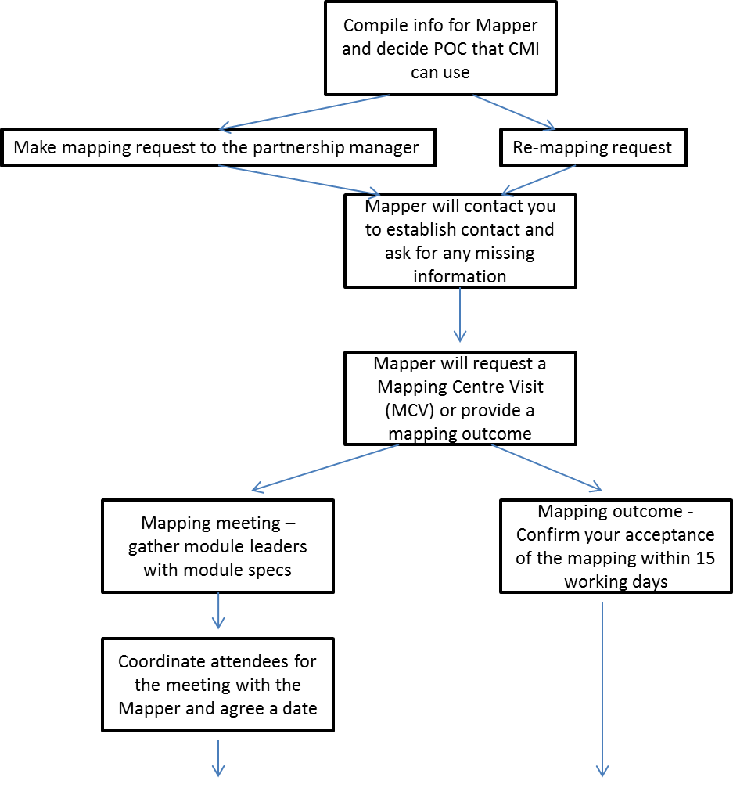
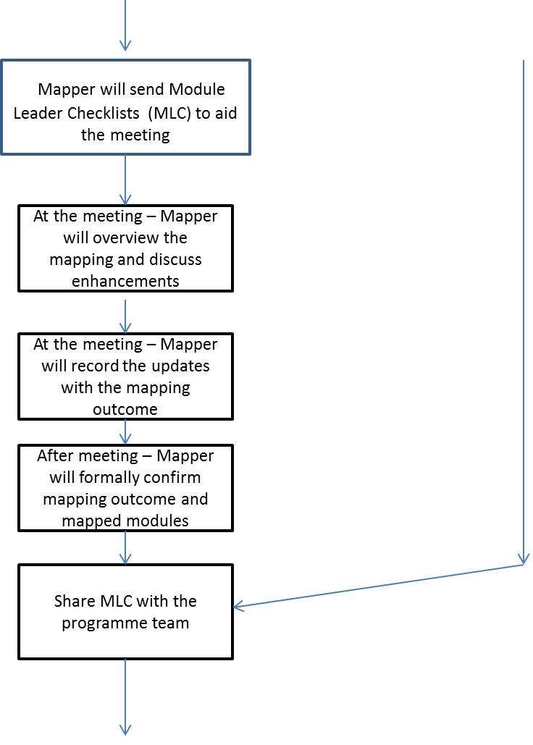
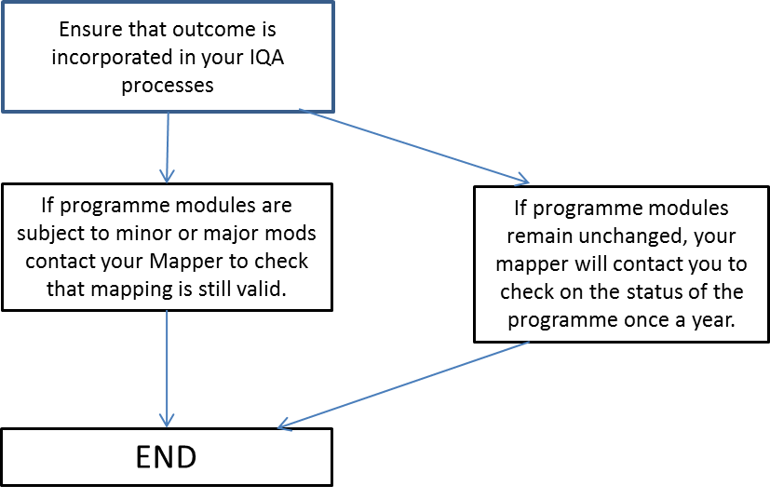
Figure 3 MAPPING FLOWCHART

The completed yearly CMI centre visit report will be returned to the Centre within 15 working days (Monday to Friday, GMT or BST) of the visit. Should remedial action be required on the part of the HE Partner, an action plan will be included in the report, with agreed timescales where necessary. Completion of actions will be monitored by CMI. The sanctions policy will apply. Centres will be unable to register Learners while a sanction level 2 or above is in place. The Quality Manager will work with you to resolve any outstanding issues to the satisfaction of both parties.

Risk Level | Sanction (from CMI Centre Sanction Policy)
Level 1 | Action points to be completed by set deadline.
Level 2 | Suspension of Registration - Action points to be completed by set deadline.
Level 3 | Suspension of Certification - Action points to be completed by set deadline.
Level 4 | Removal of approval for specific qualification(s) - Action points to be completed by set deadline.

Services available after approval
Once the mapping documentation has been approved and signed off and the HE Partner Centre approved, the HE Partner is in a position to promote the Dual Accreditation as a ‘value added’ element to its main programme. The following stages are then needed:
- Contact the relevant Relationship Manager. This person will offer valuable support to the HE Partner, ranging from supporting the marketing of the new qualification to attending open events to promote and demonstrate the benefits of gaining a CMI qualification whilst studying another qualification. They will also be able to demonstrate the Management Direct resources that are available to all CMI members.
- Learner recruitment must be undertaken in a fair and consistent manner, and so in order to achieve a CMI qualification, Learners must be registered as a CMI Learners within six weeks of the start of the delivery of the CMI element of their programme. Discuss with your Quality Manager and inform the Partnership team if this is not possible for any reason. Learners will be able to access all of the CMI benefits as affiliate members including learning resources on Management Direct.
- Once registered with CMI, each Learner will then have their own CMI Learner number and access to extensive resources on Management Direct that can be used for their course and professionally. It is the responsibility of the Programme Director at the HE Partner to ensure all Learners are registered accurately on the HUB as this information will be used to produce certificates for Learners. If support is needed with this process the partnership team at partnership@managers.org.uk will be happy to assist.

Registration for CMI Learners lasts for 5 years for an Award, Certificate, and Diploma. If Learners are likely to take longer than these periods to achieve the CMI qualification, it is the responsibility of the HE Partner to inform CMI to ask that this period is extended. If the Learners registration lapses then an additional charge may be incurred to re-register the Learners to gain certification.

CMI Moderation after approval
SEE MODERATION FLOWCHART
A CMI-appointed Moderator will need to moderate a sample of all assignments for evidence of CMI learning outcomes for each cohort according to the Conditions of Confidence.
- Moderation will take place at least once a year as required, more than once if there are multiple cohorts, around the same time as the HE Partner’s academic board/exam board meetings. Moderation can be done by several mechanisms:
  - Learners work is uploaded to the HUB or to a dedicated CMI GoogleDrive
  - The Moderator carries out a Centre visit (by special request or for first moderation only)
  - The Moderator is given remote access to the Learners work via the HE Partner’s Virtual Learning Environment (VLE) or another secure repository.

- For detailed guidance on how to upload work for moderation, please refer to the operational documentation on the CMI HUB.
- In all Moderation mechanisms, a batch of completed learner names must be uploaded to the HUB by the HE Partner. Where necessary additional documents can be attached. These documents could be the Learners work, instructions to access the VLE remotely, or a confirmation that a centre visit has been arranged with the Moderator.
- Where ALL Learners on a unit are registered for a CMI qualification then CMI is happy to use the same sample as that used by External Examiners as long as the sample represents meets current CMI moderation policy and represents the range of marks achieved. Where not all Learners on the cohort are registered with CMI, or where internal verification has deemed some Learners to not have met CMI learning outcomes and have been removed from the assignment population for CMI accreditation, please ensure that an appropriate sample of CMI Learners is made available to the CMI Moderator. Unlike the sample used for the External Examiner, CMI only requires to see passes so some adjustment may be necessary to the sample used by the External Examiner. The Conditions of Confidence for the Centre will dictate the sample size required. There may be instances where larger sample sizes are required due to moderator concerns. The HE Partner will be kept fully informed where this is the case.
- For onsite moderation visits it is the responsibility of the HE Partner to contact the Moderator or Quality Manager at least 8 weeks prior to the date of the Exam Board to arrange a suitable date for moderation. A second visit or second moderator can be arranged if there are large numbers of Learners/courses with Dual Accreditation or if the Quality Manager feels there is insufficient evidence being gathered for CMI requirements. Where possible we recommend that Moderators be granted access to the HE Partner’s Virtual Learning Environment so that moderation can be done virtually. Onsite moderation may incur additional costs.
- During moderation, the HE Partner will be asked to submit copies of assessment briefs to the Moderator who will use the original mapping document to ensure that evidence has been signposted correctly. It is essential that the original mapping documentation is adhered to as this is what was agreed before the programme commenced. Any planned changes to this document, for example if a unit specification alters or minor amendments are made by the HE Partner to the main programme, then the mapping document also needs to reflect this and it has to be resubmitted to the Moderator for approval prior to the programme commencing. See section on ‘Stage 2 Mapping’

- The expectation from CMI is that Learners are clear about what evidence needs to be generated to satisfy CMI requirements and take ownership of producing sufficient evidence to demonstrate achievement of learning outcomes. As part of their main programme of study, a range of subject areas will be covered and appropriate mapping activities undertaken by Programme Directors will ensure Learners can provide evidence for both their degree and the CMI qualification. This will be moderated by either the Quality Manager or an HE Specialist Moderator.
- Learners’ assessments need to be made available during the moderation process. The Moderator will need to see evidence of internal quality assurance to ensure that the CMI elements have been met. This can be in the form of internal verification (document examples are included on the HUB under Centre Resources) but could also be second marking that has also reviewed the CMI evidence. There needs to be clear tracking of Learners’ work by the module tutors for the CMI elements linked to the original mapping documentation. Appendix G provides a ‘List of Information Required by the Moderator’.

The Moderator must sign off the batch in order for the HUB to generate the Learners certificates so it is essential that all the Learners who require certification are included within the batch; that Learners are registered for the correct qualification and that the correct units which are being claimed are listed. These are listed in the mapping document. Please note that Moderators will not look at work that is not already included in a CMI batch.
All eligible students are registered.
MODERATION FLOWCHART
Is this the first moderation?
NO
YES
QUESTIONS?
QA or IQA queries: Elly Philpott +44 7701289489 elly.philpott@managers.org.uk
Student registrations: partnership@managers.org.uk
Uploading batches for moderation: awardingbody@managers.org.uk
Approvals: approvals@managers.org.uk

Moderator gathers 1 sample of learner work per visit/activity for CMI archives and standardisation.
Moderator completes their report.
NO
NO
Post Exam Board, complete the IQA process to check student work for CMI evidence.
On site moderation is required
Does the HE Partner require on-site moderation?

YES

Contact the moderator to agree a visit date (approx. 2 weeks after the programme(s) Exam Board(s). Allow sufficient time before certificates are required (at least 2 weeks).

Upload a batch to the HUB. Claim the students who have completed, and the CMI units being claimed.

Is the student work to be uploaded to the HUB

YES
On the HUB, upload a batch of students and attach instructions to the moderator on how to access the work (e.g. via remote access to VLE, who to contact for email copies of the work, or Dropbox access.
. Provide exam board results. Moderator will do a 15% sample of all units claimed.

Does the moderator agree the batch meets standards?

YESS
NO
Certificates are dispatched to the HE Partner.
Follow actions/comments made in the moderator report.

Resubmit the claim.
Follow actions/comments made in the moderator report and prepare for next moderation.

Delivery and Assessment in languages other than English
CMI only Dual-Accredits courses that are delivered and assessed in English.

Ensuring timely certification
Following successful moderation of course assignments, the CMI moderator will amend the cohort status on the HUB by signing off the batch on the HUB. Only Learners already registered on the HUB will be certified.

- Certificates will be issued within 5 working days after sign off; postage will be an additional 5-10 working days. It is envisaged that certificates will arrive prior to any award ceremony planned by the HE Partner but it is the HE Partner’s responsibility to check and upload batches for moderation in plenty of time before the certificates are needed. If any clarification is needed then the HE Partner must contact the Quality Manager. To celebrate the success of the Learners, it is possible a representative from the CMI may attend any award ceremony. Details of any events should be given to the CMI Relationship Manager.

CMI cannot accept responsibility for the issuing of certificates at short notice to Centres who have neglected to arrange moderation and require certificates for graduation ceremonies or other presentations. However, staff will endeavour to fulfil all requests.

All certificates will be sent to the named CMI Programme Director at the centre. If certificates need to be sent elsewhere for distribution please confirm this in writing to partnership@managers.org.uk

Archive and training requirements
Following completion of any qualification, a sample of Learners work will need to be retained for 3 years by CMI for internal CMI training purposes and Learners should be made aware of this by the HE Partner. CMI also expects that centres retain data for 3 years for audit purposes.

Suggested delivery approaches
In order to capture the most achievement for Learners, wherever possible, we suggest you ‘front load’ one or two CMI units. For example, if you deliver CMI-mapped modules early on in the programme, should the Learners leave the course early they can still achieve a CMI qualification. If they achieve two or more CMI units, they may achieve a CMI Award or Certificate. This option is also available if the Learner has been registered on a CMI Diploma qualification and is unlikely to achieve all the CMI elements. The Learner can be transferred to an Award or Certificate and attain these if they provide sufficient evidence. Decisions of this kind can only be made after moderation. To do this, contact CMI and a Customer Service Administrator will be able to transfer the Learners. By offering multiple exit points for the CMI elements, Learners can still achieve a CMI qualification for work they have completed.
Another delivery approach is for a ‘single unit’ to be used as ‘value added’ on another programme. For example, a HE Partner can use a CMI standalone unit as part of their own qualification. That way, the Learners can achieve a degree in their chosen subject area and develop the skills they need to progress into business and also become a member of CMI. There is a wide range of options available to offer units across the HE Partner. Assessment materials are already produced and Learners work can be marked by the CMI to reduce the workload of academic staff if necessary. CMI now also offers an Assessment Checking service to provide tutors with confidence that assignments are likely to evidence the required CMI Learning outcomes. This can be requested via awardingbody@managers.org.uk . A charge may apply for this service.

Annual Roles and responsibilities of HE Partner staff

Programme Director

Checking relationship documentation
- If you are a new Programme Director, ensure you are recorded as Programme Director for the Centre – contact Partnership@managers.org.uk to make changes. Once you are registered as Programme Director you will be given a username and password for the CMI hub and for CMI GoogleDrive. You should also notify CMI of any change of name for the legal signatory for your institution. This person will also have a username and password on the HUB.
- Familiarise yourself with your Regulatory Agreement (contact Partnership@managers.org.uk for a copy if necessary).
- Check the ‘Approval Documentation’ to establish the quality assurance practices approved by CMI. Review the information that your Centre provided to the CMI Quality Manager during the application process. Changes to policies, practices, processes or procedures following approval can be updated via your HUB access. This information will also be reviewed during centre visits.
- Review the previous Centre Visit Report (if available) and address outstanding actions. If in doubt, please contact your CMI Quality Manager.
- Are there any third party relationships operating and have these been approved by your CMI Quality Manager? (refer to Section 11 of the Regulatory Agreement V16)
- Is the Centre operating across multiple sites, or different locations, or in other countries and has this been approved by your CMI Quality Manager? Please note that there is a separate approval procedure for satellite centres which must be adhered to.

Co-ordinating yearly CMI centre visits
- Contact your CMI Moderator to inform them of Academic Board dates so that external moderation can be planned in advance to ensure certification is not delayed. Provide the External Moderator for CMI with the Learners’ results after the academic board and indicate which Learners are going to claim the CMI qualification.
- Make internal arrangements for the QA visits and endeavor to meet requested visit dates. Ensure that relevant staff are invited to the meeting, including representatives from different levels, other schools or faculties where they are needed. Arrange visitor parking and book a quiet room with an Internet connection and power sockets. After the visit confirm accuracy of the visit report and complete any actions by the noted deadline.

Checking Learner details on the CMI HUB
- Check the register of current Learners and compare with the CMI Report ‘Current Learners’ (from CMI HUB) to ensure all Learners are registered with CMI. Note: all Learners should be registered within six weeks of starting their programme. Registered Learners who are not going to complete the CMI qualification due to withdrawal from the course should be withdrawn from the CMI qualification. Referred or Deferred Learners should be discussed with the CMI Quality Manager.
- Review and retain evidence of current Learners’ progress and achievement for existing cohorts, and communicate with module tutors.

Checking internal records and annual moderation arrangements
- Are there any moderation reports with actions in relation to assessments, mapping etc.?
- Ensure the Module Leader Checklists are up to date and reflect current assessment practices and staff.
- Ensure two example assessment briefs for CMI-mapped modules have been verified by a CMI Quality Manager or Lead Moderator.
- Is there a sampling strategy for selecting assignments from each unit and each cohort to meet the sample required by CMI Moderators?
- Ensure that during moderation CMI Moderators are able to see work for the range of courses offering CMI qualifications. Where assignments are only available in electronic format e.g., an Intranet or Virtual Learning Environment, please either arrange electronic access for your CMI moderator or ensure that paper copies can be made available for moderation.
- Is there a secure archive (electronic or hardcopy) of Learners work? (Refer to CMI Retention of Records policy)
- Have you all of the information regarding CMI delivery across all courses? Do you communicate with all module tutors who deliver elements of CMI e.g. team meetings?
- Provide the External Moderator for CMI with the Learners’ results after the academic board and a batch of Learners to the HUB for which certification is being claimed.

Communication with tutors and checking staff records
- Review and communicate with module Tutors and share module leader checklists and the centre visit template with all staff. Communication from CMI will only be directed to the Programme Director and so information provided by CMI will need to be passed on to all staff involved with delivering CMI-accredited programmes.
- Ensure mapping is reviewed each year and updated where necessary. This should be done with module Tutors who should have a copy of the mapping and take ownership to ensure the evidence for CMI is located in Learners work (using the mapping as a guide). If the mapping needs to be altered, this should be done with agreement of the CMI Specialist Mapper. All revised mapping will need to be approved by the CMI Quality Manager and then stored centrally with CMI and old documents archived.
- Check all staff are approved and records are up to date:
  - Check the Centre Staff Record (report on the CMI HUB) and ensure all delivery and assessment staff are approved by CMI.
  - Seek approval for additional staff and/or withdraw staff by going to the approvals menu in the CMI HUB and the OUR STAFF tab. Completed Centre Staff Approvals will then assessed by your Quality Manager. Ensure that Module Leader Checklists are signed by staff and indicate who is delivering and assessing modules. These can be added to section 3.3 of CMI HUB whenever staff changes are made.
  - Ensure copies of up to date CVs are uploaded to the HUB for all delivery and teaching staff. Please delete staff who have left and remove obsolescent CVs.

Module Tutors

Demonstrating evidence
- Have a copy of the mapping documents which indicate where CMI evidence is likely to be
generated within the module.
- Ensure assessments with modules that have CMI evidence within them (indicated on the
mapping) have tasks that will generate sufficient evidence for the CMI qualification and complete a Module Leader Sign off form. See Appendices D and E.
- When Learner work is submitted for their main qualification, the module
Tutor/Deliverer/Assessor for that module also identifies where the evidence is located for CMI (following the mapping document). This can be annotated on scripts, in a table format etc., as long as the CMI evidence is also tracked within the Learners’ work.

Coordinating authenticity
- Ensure that statements of authenticity are available for all Learners.

Meeting the moderator
5. Module Tutors may need to meet with the CMI Moderator during virtual or onsite visits to discuss the module assessments.

Reconciling module changes with CMI mapping
5 If module assessments or assessment strategy alters, for example if a written exam is to be used which allows a choice of questions as opposed to a set of compulsory questions covering all learning outcomes, please inform the PD as the mapping may need to be altered to reflect this. Similarly a move to group work from other forms of assessment will result in changes to the mapping. The PD will need to discuss this with the CMI Mapping Specialist.

CMI additional support
There is a dedicated team of people at CMI that is able to offer support and advice to our HE Partners.

This ranges from Dual Branded Marketing material, complementary places on Management Direct, discounted fees for Management Direct and Chartered Manager (for larger Learners numbers only) which can also be embedded within the programmes. Please contact Partnenship@managers.org.uk or phone +44 (0)1536 207345 for support in this area. Please note that this line is only available 9am to 5pm London time.
Further information can be gained from your Relationship Manager. If you are considering delivering CMI qualifications as standalone options for students, the Customer Service team is also able to assist with queries and may be reached by email at qualifications@managers.org.uk or by ‘phone on +44 (0)1536 207496. This team can assist with registration and certification queries. Please note that this line is only available 9am to 5pm London time.
If you are moving from a Dual Accreditation model of delivery to one of direct delivery for CMI qualifications, additional training will be required for delivery and assessment staff. Please contact your Relationship Manager to discuss. Additional charges may apply.
Additional support for marketing, membership and other queries can also be obtained by contacting the Customer Service team in the first instance.

APPENDIX A: BASIC QA INDICATORS QUESTIONNAIRE WITH CONDITIONS OF CONFIDENCE
 | BASIC QA Indicators | Answers | Documentation evidence to be added to the centre’s CMI Googledrive prior to centre visit | Documentation evidence to be inspected during centre visit
1 | Consider what IT and telephony will be used to communicate with CMI. Communication may involve email, SKYPE, Use of Google Drive, transfer of batches of assignments to the CMI HUB, or downloading CMI procedural information from the CMI HUB,  Please do the ‘CMI browser capability test’. Are we compatible?  https://hub.managers.org.uk/Compatibility | After trying the compatibility test state here whether you are compatible.  The approval and mapping process may require the transfer of large files between our organisations.  State here whether you are able to use Googledrive?  Please provide the email addresses of people for whom you require Hub and Googledrive access. Usernames and Passwords will be issued from CMI, | Issues identified during the CMI IT capability test with notes for users. | Status, difficulties, work arounds
2 | Does your country’s Higher Education Quality Assurance body have a Memorandum of Understanding (MOU) with QAA in the UK? | State here whether there is an MOU in place. Provide a link to the document | Copy or URL of relevant MOU with UK QAA. NB – The duration must be clear. | MOU status
3 | Who is the Higher Education Quality Assurance body for the programme you are seeking dual accreditation for? | State here who the external quality assurance body is for the programme | Copy of Standards for Undergraduate, Postgraduate and Doctoral degree as appropriate | Changes and updates to existing information held
4 | Are you able to provide copies/URLs where needed for key quality assurance documentation?  NB – Alternatively, are you able to provide signed statements in English on the content of key policies and procedures? | Provide a link here to the university’s quality assurance documentation e.g. policies and procedures, tutor handbooks, student handbooks | Statement from University - this document.  Alternatively provide signed declaration statements on the following:  - Complaints and appeals  - Conflict of Interest  - Malpractice and maladministration  - Recognition of Prior Learning (RPL or APEL)  - Equal opportunities  - Health and Safety | Changes and updates to existing information held
5 | Is your university willing to accept CMI’s ‘Conditions of Confidence’ with regard to delivery, assessment, internal verification and moderation? | Answer yes/no | Statement from University - this document | Check in place
6 | Do delivery and assessment staff/ local administrators have an English language qualification equivalent to IELTS centre’s CMI6.0?  Please state the level of qualification, external validation or and or equivalent experience. | Describe here the standard of English amongst delivery, IV and admin staff. | Statement from the University - this document - this document | Changes and updates to existing information held
7 | Can all assignments be provided to CMI in English for CMI moderation purposes?  NB – All data including assignments must be kept for 3 years | Say here how assignments will be provided, e.g., hard copy (onsite only); softcopy via your VLE or e-portfolio; softcopy to CMI Googledrive; softcopy to CMI HUB.  State here that you understand that all data will need to be kept for 3 years including student assignments. | Statement from University - this document | Assignments for Dual Accredited modules  Changes and updates to translation services
8 | What month/s are the exam boards/committees for the courses to be dual-accredited? | Provide here a schedule of exam boards/ exam committees. CMI moderation will take once students have officially completed mapped modules.  NB – If there are multiple cohorts expecting CMI credit during the period of study then all exam boards for Dual Accredited courses will need to be notified to CMI. | Statement from University - this document. | Check for updates
9 | Have you signed the HE Regulatory Agreement? | Answer yes/no | A signed Regulatory Agreement | Check in place

10 | Is there a policy in place for Learner appeals?  Ofqual C2(i); I | Describe here your policy and procedure on appeals | Learner appeals procedure  Or signed declaration using Appendix O | Incidents checked during centre visit
11 | Is there a ‘Malpractice and Maladministration Policy’ that includes a process for reporting serious assessment malpractice to CMI?  Ofqual A8.3- A8.6 | Describe here your policy and procedure on student and staff malpractice and maladministration. | Staff and student malpractice procedure  HR Code of Conduct procedure or template contract of employment  Student contract  Or signed declaration using Appendix N | Incidents checked during centre visits.
12 | How is conflict of interest identified, documented and acted upon in relation to assessment and quality assurance processes?  Ofqual A4.1(b) | CMI’s definition of a conflict of interest can be found at: https://www.managers.org.uk/~/media/Files/PolicesProcedures/General/Conflict%20of%20Interest%20Policy.pdf  Here describe how and when a conflict of interest is declared within your quality system?  This question does not refer to quality processes generically but to the identification of conflicts of interest amongst staff e.g., if staff are asked to approve entry or mark work for their own family or friends. Some universities have an agenda item at all important meetings where people attending are asked to declare any conflict of interest in them being there. Others have regular questionnaires where staff are asked to update the faculty with any conflicts of interest in them teaching, marking or important panels. | Policy and processes  Codes of Conduct  Examination handbooks incorporating declaration of interest  Employment form incorporating declaration of interest  Or signed declaration using Appendix K | Updates and changes checked during centre visit

Condition of confidence 1 (associated with QA level 1 indicators):
If approval screening finds some level of national compliance between the HE partner and the country’s QA agency and an MOU between the country’s QA agency and our own e.g., QAA; then assessment checking prior to delivery, normal mapping, internal verification requirements and moderation would apply as per overseas CMI Centres.

Yearly audit applies.

Conditions of Confidence 2 (associated with QA level 2 indicators):
If there is some level of QA external accreditation e.g. AACSB; normal mapping, assessment checking prior to delivery, internal verification with assistance in the first year, 100% moderation in the 1st year, 50% in the second year and 20% in the third year. NB – AACSB does not cover all Ofqual requirements but does share the ethos of demonstration of all LOs in assessments.

Yearly audit applies.

Conditions of Confidence 3 (associated with QA level 3 indicators):
If there is some QA through another recognized body (some indication of school scrutiny but not necessarily at the course level) then level 3 will be considered.
However, Ofqual conditions in the areas of: management of systems, Centre management and systems; Centre staff, Centre resourcing and monitoring; equality, diversity, health and safety and data protection; Learners support and student experience, verification and assessment need to be met. Otherwise the Centre will be rejected.
If the only gap in meeting the Ofqual regulations is in verification and assessment then CMI may be able to offer additional help through provision of additional training.
For level 3 the following process would need to be followed: 1) yearly mapping, 2) yearly check of assignments prior to delivery, 3) support for IV, 4) 100% moderation in the first year, 50% in the second year and 20% in the third year.
The move to 50% or 20% moderation would only happen where there were no sanctions.
Six monthly audit would be required.

APPENDIX B: LEVEL 1-3 QA INDICATORS QUESTIONNAIRE
 | Level 1 QA Indicators | Answers | Documentation to be added to the centre’s CMI Googledrive | To be inspected during centre visit
1 | Please list any course/programme level approvals from Professional bodies, Statutory bodies,  Regulatory bodies. | To answer this question fully please address the following:  What is the status of approval for each of the courses being Dual- Accredited?  Is the approval current or when will it be obtained?  What date will the approval run to? | Documentary evidence of individual Programme approval from the national Higher Education and Quality Assurance bodies. | Status of approval for each course to be Dual-Accredited  Currency of approval  Expiry of approval
2 | Deleted |  | Documentary evidence of.  . | Review paperwork  Review reports
3 | Are there any local QA restrictions on the course?  NB – CMI is the awarding body for its own professional qualifications based on a UK framework. CMI qualifications are not academic qualifications and this should be taken into account when advertising locally. Equivalence to academic qualifications should not be claimed. | State here whether additional national QA approvals are required to offer CMI qualifications alongside your own. | Statement from University - this document | Changes and updates to existing information held
4 | Are there any government policy-based restrictions on your course/programme with regard to dealing with overseas accreditors? | State here whether government policy-based restrictions (e.g., numbers of over sees students, funding caps, distance learning content, language requirements, etc. apply. If so, what are they?  Should the current government policy change how would you notify CMI? | Statement from University - this document | Changes and updates to existing information held
5 | Deleted
6 | CMI requires that all students are registered with CMI within 6 weeks of starting their programme at the university. CMI requires that all data be retained by the centre for 3 years. CMI requires that the university assures that there is summative evidence for each learner for each of its learning outcomes. CMI requires that the centre make a claim for moderation on its system (HUB) once registered students have completed mapped modules. CMI requires that it be allowed to moderate student work. CMI requires that the centre participate in a yearly centre with CMI.  - How would any administrative processes need to change to accommodate CMI requirements, e.g., registration of students and moderation claims?  - How would any change control processes need to change to accommodate CMI requirements e.g., a review of mapping if there are any changes to module content or assignment delivery methods?  - How would any teaching processes need to change to accommodate CMI requirements, e.g., control of assessments to ensure that mapping remains current or communication with new staff?  - How would any assessment processes need to change to accommodate CMI requirements, e.g., assignment brief checking, internal verification that CMI learning outcomes have been met, or facilitating CMI moderation post exam board? | Describe here how your processes will accommodate CMI requirements | Statement from University - this document | Policies (academic regulations)  Procedures (QP)  Checklists  Inclusion of regular agenda items in review meetings  Staff induction materials

Level 2 QA Indicators - Existing external accreditation
 | Level 2 QA Indicators | Answers | Documentation to be added to the CMI Dropbox | To be inspected during centre visit
7 | Are there any other course level approvals with external bodies for the courses to be Dual Accredited by CMI? | Here describe any other approvals e.g. AACSB. Do these accreditations review at the programme or learning outcome level?  If so what level of accreditation has been achieved? When was the last audit? What was the outcome? When is the next audit date? | Documentation showing any other course level approvals for CMI Dual Accredited courses  OR  University statement, No external accreditation’ | Changes and updates to existing information held
8 | Deleted
9 | Deleted

Level 3 QA Indicators_Centre Management and Systems

 | Level 3 QA indicators | Answers | Documentation to be added to the CMI Dropbox | To be inspected during centre visit
10 | Can the following data be made available - staff details, roles, contact details. | CMI requires that tutors and assessors are approved by CMI and their details logged on the CMI HUB.  Please state here whether this information can be supplied and a list of staff for whom HUB access or membership is required. | Following approval, the CMI HUB will allow you to upload and maintain this information. NB – Following initial approval, staff lists will be reviewed yearly at centre visits. | Staff lists are checked during centre visits. CMI would also like to meet key staff.  Changes and updates to existing information held
11 | Identify a staff member responsible for CMI Learner registration, CMI achievement tracking, CMI certificate checking and effective distribution to students. | Here, full contact details will be needed. The HUB allows your Programme Director to maintain these details | Contact details | Changes and updates to existing information held
12 | Is there a procedure for accurate and timely registration of Learners? Provide details.  NB. Aim to register learners within 6 weeks of commencement of course.  We understand that this may not be possible in all cases however early registration of learners gives them individual access to CMI resources.  Ofqual G5 | State here whether the intention is to register learners at the beginning of the course, during the course or post Internal Verification/IQA and CMI moderation?  Once centre approval is granted you will be able to register learners on the HUB yourself. Registration of learners will be against CMI modules as described in the mapping document. | Statement from University - this document.  NB – Learner lists are checked yearly at each centre visit and during the moderation process. | Changes and updates to existing information held
13 | How will you ensure that learner records and details of achievements are accurate, kept up to date, securely stored and available for verification and auditing by CMI, including a Learner tracking process?  Ofqual H2  How will normal learner progress be communicated to CMI?  Students studying CMI courses may need to sign an amended registration form to declare that they understand that their study status will be shared with CMI, their work will be moderated by CMI and their work may be anonymised and used for training purposes. | Describe here how you intend to track the Learners who will be registered with CMI.  At centre visits, CMI will need visibility of the following status: normal progress, referral, deferral, lapse, change of course, confirmed student malpractice for mapped modules. Any changes can be notified to partnership@managers.org.uk  Definitions  - Student progresses normally  - Student fails module because of poor performance, lapsed attendance, or student moves course. Learners accrue CMI credit as they progress and multiple exit points may be possible. For example if the mapping indicates that a programme is a CMI certificate ( 13-38 credits); if the student fails to complete the necessary modules they may exit with a lesser award as long as 6-12 credits have been achieved.  - Referral or deferral – completion of CMI learning outcomes could be delayed and the learner may need to be moved between batches on the CMI HUB  - Malpractice – student may be found guilty of malpractice following university investigation. | Statement from University - this document | Changes and updates to existing information held
14 | Will learner fees be collected before course completion?  NB - Certificates should not be withheld whilst awaiting Learner payment. | Describe here your student payment arrangements. | Statement from University - this document | Check
15 | Are there existing agreements with third parties and sub-contractors to ensure that all policies and requirements referred to in this Agreement are enforceable with third parties and sub-contractors?  Should this status change you will need to notify CMI immediately as additional QA processes will apply before approval is granted. | Describe here any arrangements with third parties for the development, delivery or assessment of the programme/s. If there are none, state, “No third parties” | All agreements with third parties.  CMI approval document for any third parties or intended satellites. NB – there is a separate approval form required. | Changes and updates to existing information held
16 | What will be your process for issuing CMI certificates to students?  Ofqual H6 | Once CMI moderation is complete, certificates will automatically be generated and sent to the named Programme Director at the address provided. Describe here the process of checking students’ details and distributing certificates to students. | Statement from University - this document required | Changes and updates to existing information held
17 | Deleted
18 | Is there a complaints handling procedure for learners?  Ofqual 2.3 (i)  How will you notify CMI of student complaints regarding dual accredited modules? | Provide here confirmation that you have a complaints handling procedure and acknowledge the direct right of complaint to CMI.  Students on CMI dual accredited programmes have a direct right of complaint and appeal to CMI for mapped modules only. This would only apply to CMI moderation decisions and not the assessment decisions of the university. CMI would expect a student to exhaust a centres procedures before exercising direct right of appeal or complaint. | Evidence that you have a complaints procedure e.g., English copy or a signed declaration using Appendix O | All complaints will be checked during centre visits or by the CMI moderator.
Level 3 QA Indicators_ Centre Staff, Staffing Resources & Monitoring
 | Level 3 QA indicators | Answers | Documentation to be added to the CMI Dropbox | To be inspected during centre visit
19 | Does the Centre have appropriately qualified teaching/ assessing staff?  Have staff qualifications been verified? Is there evidence for this activity that can be shared with CMI  Ofqual A5.2 (a)  NB – we would expect that staff be qualified to at least the level they are currently teaching AND have a teaching qualification or five years of experience of assessment. | CMI requires that all teaching and assessment staff are qualified to the level at which they teach.  Here provide a statement that this is the case. Describe how the university verifies this itself.  The CMI HUB will allow you to upload and maintain staff information post approval. Following approval all new staff will be reviewed at centre visits. | Staff CVs.  Copies of certificates of highest level of education for the Programme Director with written consent to verify.  Permission to attest i.e. Name, dob, institution, copy of certificate and email containing the words, “ I give my permission to attest the information provided”.  Evidence of any external scrutiny of teaching staff. NB. A current national teaching permit will suffice.  NB – Module Leader checklists are provided for each mapped module. These in effect provide a proxy for a staff matrix. | Staff lists are checked during centre visits. CMI would also like to meet key staff.
20 | Is there an induction process for new Centre staff and will this include induction to CMI procedures?  Ofqual D8.1 | Here, outline of induction processes for new staff and how CMI processes can be included in this.  Will there be any regular meetings which incorporate CMI required elements? NB – quarterly meetings are considered good practice.  Will CMI be a standard agenda item on reviews of external professional programmes? | Statement from University - this document | Processes  Outputs or materials from induction  Minutes of regular meetings  Changes and updates to existing information held
21 | How does the Centre support and record the Continual Professional Development (CPD) of staff for CMI delivery?  Ofqual D8.1 | Here provide detail of how staff continually develop their subject content, teaching and assessing skills. E.g., research, teaching and learning activities. | Statement from University - this document | Evidence.  Changes and updates to existing information held
22 | How will you ensure that teaching and assessing staff have sufficient time for programme planning, delivery, assessment, internal verification and standardisation activities for courses that carry dual-accreditation from CMI?  Ofqual C 2.3(f) and 2.3 (g) | NB – the requirement to Internally Verify CMI learning outcomes are met in all assignments means that additional time may be required to check that assignments on Dual Accredited modules are fit for purpose before they are accepted and to check learner work before batches are uploaded to the HUB for moderation.  Please acknowledge in your reply that this is understood. | Statement from University - this document | Documents indicating how assignment checking and Internal verification is managed  Changes and updates to existing information held.

Level 3 QA indicators_ Equality, Diversity, Health & Safety, DATA PROTECTION
 | Level 3 QA indicators | Answers | Documentation to be added to the HUB | To be inspected during centre visit
23 | What is the provision for equal access for Learners, special consideration, reasonable adjustments, equality and diversity?  Ofqual G6 and G7 | When answering this question please describe the following:  - Entry criteria  - Any circumstances where delivery or marking is adjusted to accommodate students’ needs e.g., personal circumstance, disability, cultural norms | Statement from University - this document  Policies  Or a signed declaration using Appendix H | Examples of equal access, special considerations, reasonable adjustments, equality and diversity considerations.  Changes and updates to existing information held
24 | Are there effective monitoring systems in place for equality and diversity?  Ofqual C2.3 (h) | When answering this question please describe the following:  - How does your university assure that students are not discriminated against? | Statement from University - this document  Policies  Procedures  External recognition | Minutes of meeting  Committee members  Changes and updates to existing information
25 | How is the personal data of individual learners protected?  NB - Amendments may be needed to existing documentation to accommodate CMI access to learner status and learner work. | CMI will require your university to share student data with it. In answering this question please consider the following:  - How does local or national data protection legislation marry with CMI’s Privacy Policy: https://www.managers.org.uk/policies/privacy-policy  - How students will be notified that their data is shared with CMI. | Copy of template declaration / registration form accommodating CMI need for data access.  Or a signed declaration using Appendix L | A record that CMI Learners have signed the required forms is checked during centre visit  Any changes and updates to existing forms

Level 3 QA Indicators_Learner Support and STUDENT EXPERIENCE
 | Level 3 QA indicators | Answers | Documentation to be added to the HUB | To be inspected during centre visit
26 | Is there a Learner recruitment process that ensures Learners are on appropriate courses | Describe here how learners are recruited and evaluated before being registered on your courses. | Policy and procedures  Sample of registration form. | Changes and updates to existing processes
27 | Does the Centre have an effective process for Recognition of Prior Learning (RPL), exemptions and progression?  Ofqual E10 | CMI does not accept exemptions for mapped modules but may consider recognition of prior learning on a case by case basis. This however must be declared and evidence provided when students are registered.  Please describe here any APEL A or B arrangements or any grade transfer arrangements for the programmes to be mapped. | Statement from University - this document.  Policy and procedures  Or a signed declaration using Appendix M | Changes and updates to existing processes
28 | How does the Centre intend to consult with Learners, staff and other stakeholders as part of all programme review processes? | Describe here how student, staff and external stakeholder feedback is actively sought for the programme/s mapped. If there is an external examiner, please state who this is and what percentage of the work is looked at. | Statement from University - this document | External examiner reports for the courses that we Dual Accredit  Changes and updates to existing processes
29 | Deleted
30 | Is there adequate provision of physical resources to support learning and assessment? E.g., VLE, wifi, telephony, broadband  Ofqual A5.2 | Describe here what facilities and tools are provided to students to support their studies. NB – All registered students will have access to CMI ManagementDirect. | Statement from University - this document | Checked during centre visits.  IT capability test can be used to test IT as it evolves.  Changes and updates to information held will be checked
31 | Is there support for students with regard to avoiding plagiarism and avoiding buying in assignments?  . | Guidance on referencing and avoiding plagiarism will be available on the CMI website.  Describe here how the university explains and deters plagiarism and the buying in of assignments. | Policy and procedures  Tools | Changes and updates checked during centre visit
32 | Deleted
Level 3 QA Indicators_Assessment & Verification
 |  | Level 3 QA indicators | Answers | Documentation to be added to the CMI Dropbox | To be inspected during centre visit
33 |  | Deleted
34 |  | Are there clearly defined assessment procedures across all assessors, locations, units and Learners  Ofqual E5.1  How do you ensure that assessment documentation is clear and consistent across all qualifications?  Ofqual G3; G9; G1.1; D1.1; E4.2 | Describe here your assessment and internal verification (IQA) policies and procedures. | All relevant assessment policies  Mapping with agreed assignment methods | Changes and updates checked during centre visit.
35 |  | Deleted
36 |  | What system is used to ensure the authenticity of Learner work?  Ofqual G8 | Describe here how you ensure the authenticity of student work i.e. The person handing in the work actually did the work being handed in.  This is usually done through the physical or electronic signing of self -declarations.  NB – this is different to originality which is what software like Turnitin does. | Detail of process or Software used including how it is used. | Checked during centre visit
 | 37 | How will you ensure that your assignment briefs have suitable tasks and are linked to appropriate assessment criteria; particularly CMI learning outcomes?  Ofqual G3; G9; G1.1; D1.1; E4.2 | Describe here how you will ensure that module tutors address CMI-required learning outcomes in their assessments. Also describe how new tutors will be made aware of these requirements.  CMI can provide templates for tutors to track student progress in meeting CMI learning outcomes. These templates could be attached to assignments so the student can check whether they have met our learning outcomes. | Mapping with agreed assignment methods and learning outcomes | Check any agreed changes to mapping documents
 | 38 | Will there be a clear internal verification process to check that assessments include CMI Learning outcomes and an internal verification process to check that completed assignments evidence CMI Learning outcomes before telling Learners results. Ofqual D1.2; E4.2 | CMI will require that the university conducts an Internal Verification(IQA) process to confirm that student assignments demonstrate the CMI learning outcomes prior to batch submission for moderation. Please acknowledge in your answer that you understand this. | University statement on how it will verify that CMI LOs will be met | Checked during the centre visit  Moderation reports will also be checked during centre visits
 | 39 | Are there regular minuted team meetings to discuss CMI delivery, assessment, verification and standardisation activities?  Ofqual D3 | Describe how discussion of CMI issues will be accommodated in existing department or faculty meetings. Which groups/committees will need to know about CMI?  NB – Good practice amongst existing universities shows that this is done quarterly or half-yearly  CMI would expect that when any changes to the programme are made e.g., learning outcomes, assessment methods, this would instigate a review of the mapping. | A Statement from University - this document on how CMI issues will be picked up/addressed/reviewed | Minutes  Changes and updates to the processes of review  Mapping status
40 |  | Will there be a cycle of programme review to improve quality of learning experience.  Ofqual D3 | Describe here how the programmes to be mapped are reviewed and how often. | Documentation on Programme review e.g. External Examiner’s report | Changes and updates to processes of review
41 |  | How will you ensure that there is an appropriate range of Learner evidence available for review by CMI moderators after exam boards?  Ofqual E4.2 (e) | Describe how you will make student work available and how you will facilitate the CMI Moderator to access the student work.  NB – If an entire cohort is registered for dual accreditation then the same sample used by the external examiner can be used by the CMI moderator.  CMI requires that all assignment scripts and assignment briefs should be available to our moderators until batches are signed off for certification. In addition. No award can be made until CMI moderation has been completed. In addition we require that scripts and assignment briefs be retained for 3 years. | Process to facilitate moderator access to completed assignment and assignment briefs– may include accessing the university’s VLE or using CMI’s Googledrive | Changes and updates to processes checked during centre visit
42 |  | Deleted
43 |  | Moved earlier
44 |  | Moved earlier
45 |  | Moved earlier
46 |  | How does the centre propose to maintain confidentiality of assessment material.  Ofqual G4 | Here describe your internal arrangements for maintaining the confidentiality of assessment briefs and completed assessments. | University statement on how assessment material is kept confidential. | Physical or cloud repositories to be checked.

APPENDIX C: PREPARATION FOR QA VISIT - CHECKLIST

Documentation to support initial questionnaire responses in terms of the following subjects:

- Professional, statutory and regulatory requirements affecting the courses
- Evidence of the relationship between the University and the national QA standards body
- Evidence of ALL policies relating to the implementation of the Regulatory Agreement
- Internal governance, policies and procedures relating University governance with that of the course to be Dual Accredited
- Course level Quality Assurance documentation e.g., quality manual or operations manual
- Proof of any other external course accreditation
- Documentation relating to procedures around student experience including student appeals
- Evidence of student feedback on the courses that are to be accredited
- Processes that relate to control of course content and the setting and marking of assessments; internal verification for CMI, moderation, dealing with exceptions and changes, communicating with CMI
- Procedures around course review. Evidence of course reviews.

APPENDIX D: TEMPLATE FOR MODULE LEADERS’ SIGN OFF SHEETS
The following pages are intended for use by module leaders. This is a module-by-module plan of which CMI unit LOs map to the HE Partner module. Prior to moderation, please send a sheet for each mapped module to the Module Leader to use and sign it.
Ultimately it is the HE Partner’s responsibility to ensure the CMI Learning outcomes are covered. As each HE Partner module is in a separate table it is easier for distribution and identification by the Module Leaders. The template needs to show which CMI units are mapped (green and amber).
Insert additional rows as required if the module maps to more than one CMI unit.
Insert additional pages for each module.
HE Partner module number | Indicate whether submitted assignments for the module will be translated into English for CMI moderation | Insert the name of the HE Partner module and abbreviation used in any tables | HE Partner credit value of unit | Notes on how the module is assessed – note that exams should not be mapped unless absolutely necessary. This should be found in the course/module specification e.g. 80% dissertation, 20% presentation
Insert CMI unit number and name | YES/NO | LO1 name | Module leader’s confirmation that their assessment will cover the CMI learning outcome  Yes/No
 |  | LO2 name | Module leader’s confirmation that their assessment will cover the CMI learning outcome  Yes/No
 |  | LO3 name | Module leader’s confirmation that their assessment will cover the CMI learning outcome  Yes/No
 |  | LO4 name | Module leader’s confirmation that their assessment will cover the CMI learning outcome  Yes/No

Module leader name and signature: Date:

APPENDIX E: DISCLAIMER

Please note that the mapping exercise is based on the information supplied at the time of mapping. Subsequent minor modifications to units may change the mapping outcome. It is the Centre’s responsibility to ensure that mapping is reviewed annually to ensure that any changes have not altered mapping outcomes. Major changes such as revalidation will require remapping activity.
Learners who achieve lower grades on HE Partner modules mapped to CMI units may struggle to demonstrate full achievement of the CMI criteria. The Centre IQA process should ensure that the CMI criteria are met in full by all Learners for whom qualifications are being claimed.

APPENDIX F: LIST OF INFORMATION REQUIRED BY THE CMI SPECIALIST MAPPER
During Dual Accreditation, provision of the following information will maximise the efficiency of the mapping process for both CMI and the HE Partner.
- Evidence of national validation of the courses to be mapped e.g. correspondence from the national HE Quality Assurance body.
- Evidence of external scrutiny of the course/programme e.g., reports from an external examiner or another accreditation body.
- Evidence of HE Partner validation of the course/programme to be mapped e.g., ‘HE Partner validation / course overview document’.
- Validation/course overview documents should include the following to facilitate mapping:
    - Evidence of the course/programme level e.g., undergraduate, postgraduate or other.
    - Reference to the external standard used to decide the level.
    - The full name and code of the course/programme at the HE Partner.
    - Detail on individual units/modules in the course/programme to include the following:
        - Which units/modules are compulsory?
        - Which units/modules are optional?
        - What are the learning outcomes for each unit/module?
        - What is the relationship between individual unit/ module learning outcomes and the assessment methods used?
        - Detail on the assessment method. The words ‘coursework’ or ‘assessed project’ are not specific enough to use in mapping. We need the ‘detail of how’ something is assessed and ‘the format that the assessment evidence takes’.
Examples of suitable forms of evidence are project-based products, written assignments, written observations, evidence of professional discussion, reflective statements, a portfolio of work, a presentation, a webinar, contributions to online discussion. Other forms of evidence exist.
    - Information on time limits / arrangements on referral or deferment (NB - This may affect unit combinations for the end qualification)

Specific criteria need to be met to enable mapping against examination/test based OR Group work assessment methods due to CMI’s regulatory requirements which prescribe that all learning outcomes are covered by the individual student. You are advised to discuss mapping opportunities with your designated Mapper for modules where examinations or group work are considered to map to CMI learning outcomes.

APPENDIX G: LIST OF INFORMATION REQUIRED BY THE MODERATOR
Moderation Document Checklist
Mapped Module | Documents required for each Mapped Module | Check (Tick to show document available for the Moderator)
xxxxxxxxx  xxxxxxxxx  xxxxxxxxx | Module Handbook
 | Assessment briefs if not in module handbook
 | Samples of assessed, passed learner work across mark ranges except fails/refers. NB – the sample size will be dictated by the Centre’s Conditions of Confidence.
 | Examples of second marking and any documentation that evidences how the marks were agreed between markers
 | Evidence that relates to assessment approval
 | Any CMI evidence tracking documentation
 | Verified Learner result list e.g., from a recent exam board
 | End of Year module review
 | External Examiner Feedback

APPENDIX H: DIVERSITY AND EQUALITY DECLARATION
National or local laws
(Add a list of relevant local and national laws if applicable. If none exist write “Not Applicable)

I, (name and job role) confirm on behalf of (organisation name) that Diversity and Equality and a commitment to ensure that unlawful or unfair discrimination, whether direct or indirect is eliminated both in access to, and assessment of, its qualifications. This is promoted and enshrined in its policies and procedures.

Signature

Date

CMI Statement
CMI is committed to ensuring that equality and diversity aspects are considered at all times in the design, development and delivery of its qualifications. Dual accreditation is one mode of delivery of its qualifications and hence this ethos translates internationally.
Where it is reasonable and practical to do so, it will endeavour to address identified inequalities or barriers that may arise within the constraints of national and local laws internationally.
END

APPENDIX I SPECIAL CONSIDERATIONS DECLARATION
National or local laws
(Add a list of relevant local and national laws if applicable. If none exist write “Not Applicable)

I, (name and job role) confirm on behalf of (organisation name) that Special Considerations is enshrined in its policies and procedures and / or national or local laws in the ways listed below.

Signature

Date

Definition
Definition must concur with the following:
The term “special consideration” is a temporary experience that prevents the Learner from being able to demonstrate his or her full capability in an assessment. For example, this could be disruption or adverse conditions during the assessment or a very recent event such as bereavement. Special Consideration is only required if the Learner’s ability is impaired at the time of the assessment; therefore it cannot be planned for. For example, if the Learner cannot attend the assessment due to being on holiday, this is not a Special Consideration.

Policies and procedures
The Centre will review the information provided by the Learner or the Learner’s representative and will make a judgement upon whether Special Consideration will be applied. The Centre will gather evidence from the Learner to support their claim for Special Consideration.
The CMI Centre must report any special consideration arrangements it has made for individual Learners to CMI at the time of CMI moderation.

APPENDIX J REASONABLE ADJUSTMENT DECLARATION
National or local laws
(Add a list of relevant local and national laws if applicable. If none exist write “Not Applicable)
I, (name and job role) confirm on behalf of (organisation name) that Reasonable adjustment of student assessments is enshrined in its policies and procedures and / or national or local laws in the ways listed below.
Signature
Date

Definition
Definition must concur with the following:
The term Reasonable Adjustment refers to an adjustment of the delivery and/or assessment of a CMI qualification in order to alleviate or remove the effects of a substantial disadvantage for a Learner.
Some examples of what is reasonable could be;
• difficulty in reading and understanding written material where this is in the person’s native language, for example because of a mental impairment, a learning difficulty or a sensory or multi-sensory impairment;
• persistent distractibility or difficulty concentrating;
• difficulty understanding or following simple verbal instructions.

Reasonable adjustments could include:-
● Changing standard procedures, such as delivery or assessment procedures;
● Adapting the programme, modifying teaching delivery or providing alternative forms of assessment;
● Adapting facilities, such as IT facilities;
● Providing additional services, such as a sign language interpreter or learning materials in alternative formats;
● Providing rest breaks or practical support;
● Training staff to understand their responsibilities;
● Altering the physical environment to make it more accessible. However Centres must be mindful that any adjustment made must not:-
● Disadvantage other Learners, if the adjustment made results in an unfair advantage;
● Change the learning outcomes or assessment criteria within the qualification which would undermine the validity of that qualification;
● Affect the quality assurance processes and decisions of internal and external assessors; The key to reasonable adjustment is that it must never affect the validity or reliability of assessment, influence the outcome of assessment or give the Learner(s) in question an unfair assessment advantage.

Policy and Procedures

The Centre will review the information provided by the Learner or the Learner’s representative and will make a judgement upon whether Reasonable Adjustment will be applied. The Centre will gather evidence from the Learner to support their claim for Reasonable Adjustment.
The CMI Centre must report any Reasonable Adjustment it has made for individual Learners to CMI at the time of CMI moderation.

END

APPENDIX K CONFLICTS OF INTEREST DECLARATION
National or local laws
(Add a list of relevant local and national laws if applicable. If none exist write “Not Applicable)
I, (name and job role) confirm on behalf of (organisation name) that Conflicts of Interest in its staff are identified and mitigated and this principle is enshrined in its policies and procedures in the ways listed below.

Signature

Date

Definition
Centre definition must concur with the following:
Conflict of Interest - a conflict of interest exists in relation to CMI or its centres where –
(a) its interests in any activity undertaken by it, on its behalf, or by a member of its Group have the potential to lead it to act contrary to its interests in the development, delivery and award of qualifications in accordance with its Conditions of Recognition,
(b) a person who is connected to the development, delivery or award of qualifications at a centre has interests in any other activity which have the potential to lead that person to act contrary to his or her interests in that development, delivery or award in accordance with the awarding organisation’s Conditions of Recognition, or
(c) an informed and reasonable observer would conclude that either of these situations was the case.
Adapted from Ofqual Handbook (2017), https://www.gov.uk/guidance/ofqual-handbook/section-a-governance, last accessed 050718

There are a number of potential conflicts of interest, but some common examples could include:
● A member of staff has a relative that is undertaking a qualification with the CMI centre
● A member of staff of the Centre undertaking a CMI qualification at that Centre
● Internal Quality Assurance staff have responsibility for signing off their own assessments
● A member of staff assessing the work of a friend, acquaintance or family member undertaking a qualification with the CMI centre
● A member of staff having sole responsibility for the appointment, supervision, promotion or performance review of a person with whom they have close ties (e.g. friend, family member)
● A member of staff whose pay is influenced by positive assessment results
● A member of staff working with another employer that is in direct competition with the CMI centre
● A member of staff using non-public CMI Learner or employer data for personal gain
● A member of staff or a contractor that is both employed by the centre and an employer whose learners they teach or assess
● A member of staff using Learner work for commercial gain or advantage
● The relationship between the Internal Quality Assurance staff and the assessors lacks independence and objectivity

Policies and procedures
Policies and procedures must be commensurate with the following:

Managing Conflict
The CMI centre will firstly try to eliminate the conflict, by assigning another member of staff to undertake the activity. By doing so, this reduces the risk of assessments being compromised and ultimately assessments being voided.
Where elimination is not possible due to financial or/and resource implications the CMI centre will put measures in place which can demonstrate that the conflict is being managed effectively so as not to compromise the outcome of the assessment. Key principles here are transparency and mitigation.

Recording Actions
The CMI centre will contact CMI and set out the arrangements in place to ensure that the quality of the qualification is not compromised.
A register of Conflicts of Interest should be maintained and updated at least annually. Your Quality Manager may ask to view this register at the annual quality assurance visit.
Where Conflict of Interest is identified, the CMI centre will record as a minimum:
● What the conflict of interest is (i.e. Assessor A has a sibling X undertaking a qualification with CMI centre
● When it was identified (i.e. date)
● Who is responsible for managing the conflict of interest (i.e. internal quality assurer, centre manager, Quality Manager)
● What measures / actions have been implemented to manage this (i.e. Sibling X will be assessed by Assessor B, or where this is not possible the Internal Quality Assurer will ensure greater sampling of sibling X including in-depth questioning, or CMI external assessment service will be utilised.)
● What review mechanisms have been implemented to monitor (i.e. learner interviews, increased sampling)
● When the conflict of interest ceased to be a concern (sibling X left / completed the programme)

These records will be retained for the CMI to view upon request.
END

APPENDIX L STUDENT DATA PROTECTION DECLARATION
National or local laws
(Add a list of relevant local and national laws if applicable. If none exist write “Not Applicable)
I, (name and job role) confirm on behalf of (organisation name) that students who we register with CMI are made aware by us that their data will be shared with CMI in the following ways as defined in CMI’s Data Privacy Policy abridged below:
Signature
Date

Definition
Definition must concur with the following:

Policies and procedures

Members and registered users

If you are a member of CMI or a Friend of CMI we hold the following additional information about you for the purpose of administering your membership;
- Title (e.g. Mr./Miss/ etc)
- First Name
- Surname
- Date of Birth
- Gender
- Email Address
- Phone Number
- Postal Address
- Other information you voluntarily provided to us (e.g. sector, education, employment details, nationality etc)
- Where you are a user of our online CPD tool. CPD information that you enter
- Any CMI committees or communities that you may be a member of.
CMI uses this information in the following ways:
- To provide students with information about CMI events, newsletters, research, surveys, CMI communities that may be of interest to them, and such products or services a student requests from us or which we feel may be of interest to them;
- To provide students with services under their membership agreement or any other contract we make with them; and
- To notify students about changes to our services.
CMI retains information about its members for the duration of their membership agreement and for a period of 12 months following the expiry of membership, except as required to protect its legitimate interests or those of third parties, or (as set out below) to enable us to attest qualifications or membership, after which time it will erase all data other than that needed to comply with our statutory and regulatory obligations.
Please note that university students are registered with CMI for a period of 5 years.
Active learners on Dual Accredited courses
If you are a student or Apprentice on a course that provides Chartered Manager accreditation we will receive the following information about you from you or your training provider or employer:
- Title (e.g. Mr./Miss/ etc.)
- First Name
- Surname
- Date of Birth
- Gender
- University email address
- Postal Address
- Telephone Number
- Start Date of Qualification
- Expected Completion Date of Qualification
- Expected Graduation Date
- Your assignments
If students gain Chartered Manager status with CMI it may publish their name within the media in the year in which, or the year after, they achieve this status, in celebration of this achievement.
CMI will use their personal data during their course and for 12 months after it is completed to register them on the relevant CMI qualification and as an affiliate member of CMI, and to give them access to learning resources under our contract with your training provider or employer. Where this includes membership of CMI it will also use this information in the way described in "Members and Registered Users".
After that time, except as required for purposes connected with your continuing membership of CMI, protecting its legitimate interests or those of third parties, or (as set out below) to enable CMI to attest qualifications, CMI will erase all data other than that needed to comply with our statutory and regulatory obligations.
Attesting qualifications or membership
For former members and former learners CMI retains the information required to process certificates or to attest certificates as requested by students or on their behalf (e.g.. for a new employer). This information includes replacement certificate record, record of lost/stolen/destroyed certificate, centre name, centre number, learner name, learner number, title of qualification completed, date of qualification completed, home address at time of qualification, date of birth, last known email address.
END

APPENDIX M RECOGNITION OF PRIOR LEARNING DECLARATION
National or local laws
(Add a list of relevant local and national laws if applicable. If none exist write “Not Applicable)
I, (name and job role) confirm on behalf of (organisation name) that its Recognition of Prior Learning (RPL) processes are commensurate with those described below and recognise that CMI will consider RPL on a case by case basis and that a RPL claim must be made when a student is registered.

Signature

Date

Definition
Centre’s definition must concur with the following:
“Recognition of Prior Learning (RPL) is the –
Identification by an awarding organisation of any learning undertaken, and/or attainment, by a Learner –
i. Prior to that learner taking a qualification which the awarding organisation makes available or proposes to make available, and
ii. Which is relevant to the knowledge, skills and understanding which will be assessed as part of that qualification, and
iii. Recognition by an awarding organisation of that learning and/or attainment through amendment to the requirements which a Learner must have satisfied
before the Learner will be assessed or that qualification will be awarded.

Policies and procedures
When to use RPL
The RPL process is relevant where a Learner has evidence of having previously learnt something but has never received formal recognition for it through a qualification or other form of certification.
Evidence can draw on any aspect of a Learner’s prior experience including:
• education and training
• work activities
• community or voluntary activities.
Centres wishing to undertake RPL must ensure that:
• Evidence used for RPL must be a maximum 5 years before that date of application
• the evaluation process it is carried out by CMI approved Centre staff with relevant levels of expertise to meet CMI requirements.
• The centre has approval from their Quality Manager for any change to approved assessment methodology. RPL is considered by CMI on a case by case basis for students on Dual Accredited programmes and must be claimed when the student is registered.
The methods of assessment used will be determined by the assessment strategy for the dual accredited module being assessed and might, for example, include:
• examination of documents
• expert witness testimony
• reflective accounts
• professional discussion

The RPL assessment should be carried out as an entire process by the centre. This means that the Assessor should:
• Plan with the Learner
• Make a formal assessment decision
• Feedback assessment decisions to the Learner, confirming decisions and giving guidance on the available options (particularly in situations where the decision has been not to award credit)
• Maintain appropriate records
• Ensure that Learners are aware of their right to access the appeals process should they feel the assessment decision was unfair

The Assessor must ensure that all CMI learning outcomes being claimed are covered and that records of assessment are maintained in the usual way.

END

APPENDIX N MALPRACTICE AND MALADMINISTRATION DECLARATION
National or local laws
(Add a list of relevant local and national laws if applicable. If none exist write “Not Applicable)
I, (name and job role) confirm on behalf of (organisation name) that its Malpractice and Maladministration processes for staff and students are commensurate with those described below and recognise that CMI must be notified of confirmed malpractice with students or staff related to dual accredited modules at the time of the decision.

Signature

Date

Definition
Malpractice
The term malpractice covers any deliberate actions, neglect, default or other practice that compromises, or could compromise:
• The assessment process
• The integrity of a regulated CMI qualification
• The validity of a result or certificate
• The reputation and credibility of CMI
• The CMI qualification or the wider qualifications community
• The confidentiality of assessment materials
Malpractice may include a range of issues from the failure to maintain appropriate records or systems to the deliberate falsification of records in order to claim certificates.
Failure by a CMI Centre to deal with an identified issue may in itself constitute malpractice.

Maladministration
The term maladministration relates to any activity, neglect, default or other practice that results in the CMI Centre or Learner not complying with the specified requirements for delivery of the qualifications as set out in the relevant codes of practice, where applicable.

Types of Malpractice
The following list gives some examples of the types of incident that may occur, the list is not exhaustive:

CMI Centre Malpractice

Examples of CMI Centre malpractice could include:
• Insecure storage of assessment instruments and marking guidance
• Misuse of assessments, including inappropriate adjustments to assessment decisions
• Failure to comply with requirements for accurate and safe retention of Learner evidence, assessment and internal verification records
• Failure to comply with Awarding Body procedures for managing and transferring accurate Learner data
• Excessive direction from assessors to Learners on how to meet national standards
• Deliberate falsification of records in order to claim certificates.

‘CMI approved staff malpractice’ means malpractice committed by a current (or former) member of staff (or contractor) at a CMI Centre. It can arise through, for example:
• A breach of security (e.g. failure to keep material secure, tampering with coursework etc.)
• A breach of confidentiality (e.g. failure to maintain confidentiality of assessment materials)
• Deception (e.g. manufacturing evidence of competence, fabricating assessment or internal verification records)
• The provision of improper assistance to Learners (e.g. permitting the use of a reasonable adjustment over and above the extent permitted CMI policy, prompting Learners in assessments by means of signs or verbal or written prompts)
• Provision of inaccurate or misleading information to Centre staff about CMI qualifications
• Failure to adhere to regulations/CMI stated requirements e.g., declaration of Conflict of Interest.

Learner Malpractice

Malpractice by a Learner in internal assessment could occur in:
• The compilation of portfolios of internal assessment evidence
• The presentation of practical work
• The preparation and authentication of coursework
• Conduct during an internal assessment
• Conduct during an external assessment.
Examples of Learner malpractice could include:
• Plagiarism - failure to acknowledge sources properly and/or the submission of another person’s work as if it were the Learner’s own
• Collusion with others when an assessment must be completed by individual Learners
• Copying from another Learner (including using ICT to do so)
• Impersonation - assuming the identity of another Learner or having someone assume your identity during an assessment
• Inclusion of inappropriate, offensive, discriminatory or obscene material in assessment evidence. This includes vulgarity and swearing that is outside of the context of the assessment, or any material of a discriminatory nature (including racism, sexism and homophobia)
• Inappropriate behaviour during an internal assessment that causes disruption to others. This includes shouting and/or aggressive behaviour or language and having an unauthorised electronic device that causes a disturbance in the examination room
• Frivolous content - Producing content that is unrelated to the question in scripts or coursework.

Policies and Procedures
Irrespective of the underlying cause or the people involved, all allegations of malpractice in relation to delivery and assessment need to be investigated in order to protect the integrity of the CMI qualification and that of the academic partner to be fair to the CMI Centre and all Learners.
CMI Centres/CMI approved staff are responsible for:
• Immediately notifying CMI of any incidents, or suspected incidents, of malpractice/maladministration as required by CMI policies
• Complying with published CMI malpractice procedures
• Taking reasonable steps to prevent malpractice/ maladministration from arising
• Advising Learners of the CMI policy on malpractice/maladministration during their induction
• Being vigilant to possible instances of malpractice and maladministration
• Assisting with any CMI requests for information
• Co-operating with CMI malpractice/maladministration investigations
• Carrying out investigations of malpractice under the guidance of CMI
• Implementing any actions required during and after investigation into a case of malpractice
• Taking action required to prevent the recurrence of malpractice/maladministration.
END

APPENDIX O COMPLAINTS AND APPEALS DECLARATION
National or local laws
(Add a list of relevant local and national laws if applicable. If none exist write “Not Applicable)
I, (name and job role) confirm on behalf of (organisation name) that its Complaints and Appeals processes are commensurate with those described below and recognise that students have a direct right or appeal and complaint to CMI for mapped units if they remain unsatisfied having exhausted its internal processes. This will be communicated to students by it to students registered by it with CMI.

Signature

Date

Definition
Complaint
The term “complaint” is a statement in which you express your dissatisfaction with a particular situation.
A complaint may relate to, for example:
● A failure to provide a service or an inadequate quality or standard of service
● Wrong information about academic programmes
● The quality and availability of facilities and learning resources
● Accessibility of assessment
● The behaviour of a member of staff.

Policy and Procedures
Complaint Procedure
All CMI Centres are required to have their own complaints process. If a Learner has a complaint they must follow their Centre’s own complaints procedure in the first instance. Then, if they are not satisfied with the outcome of the internal process they can refer to CMI. See: https://www.managers.org.uk/~/media/Files/PolicesProcedures/General/Complaints%20Procedure.pdf

Get more information by calling

01536 207 496

CMI

Management House, Cottingham Road

Corby, Northamptonshire NN17 1TT

Tel: +44 (0) 1536 204 222 Fax: +44 (0) 1536 201 651

www.managers.org.
u

k

Please Note: the CMI HUB is a web-based repository for all Partner information at https://hub.managers.org.uk
May not be available due to timing of Moderation activity
May not be available due to timing of Moderation activity

