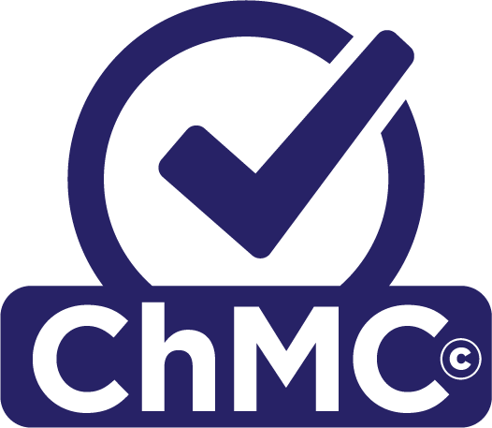
Chartered Management
Consultant Application

Applicant Contact Information
Name: |  | Please call me:
Job title: |  | Employer Name:
Contact email address: |  | Contact Phone number:

Sponsor Contact Information
Sponsor name: |  | Sponsor job title:
Sponsor email address: |  | Sponsor telephone number:

Eligibility Route to ChMC Status:
Experienced Professional |  | Please check this box to confirm that you have the minimum required 7 years’ of experience operating as a management consultant.

Please check this box to confirm that you operate in a professional and ethical manner which supports the
CMI Code of Conduct and Practice and that you are committed to completing annual CPD and maintaining records in support of this.
Please check this box to confirm you are happy to share your information with CMI for the purposes of undertaking the Assessment, and to confirm you have read and understood how this data will be held and processed by CMI.

I confirm that my application is complete, that each section adheres to the word count limitations, and all statements made by me in this submission form are true and correct

PART 1: Your case for being Chartered

Describe your current role, responsibilities and achievements. Make your case for why you should be awarded ChMC status. Focus on evidencing the Chartered level criteria highlighted for this section. You can refer to the ChMC Framework for further guidance.

Use the following headings for this section:
- Your current role, level of authority/responsibility and key outputs
- A summary of your career journey to date
- Your case for becoming a ChMC

You have a maximum of 750 words for this section.

Chartered criteria: Demonstrates contribution to the development of a pipeline of new and existing clients, continually building an extensive network of external contacts and trusted relationships within relevant organisations, industry bodies and intermediaries. Demonstrates taking responsibility for managing project delivery, operational risks, and the subsequent delivery of value based client benefits within internal KPIs. Demonstrates ability to engage and influence team members, through effective collaboration, to achieve objectives.

PART 2: Your impact as a Management Consultant

Describe TWO (2) showcase examples of your work as a Management Consultant. Focus on evidencing the Chartered level criteria highlighted for each example. You can refer to the ChMC Framework for further guidance.

For each example, please use the following headings:
- A description of the project, including your role, client expectations/requirements and timescales
- Key outputs/achievements and the impact on your client and its people
- The impact on you and your practice and/or your team

You have a maximum of 1250 words for this section.

An example demonstrating how you have led and managed others to develop, manage and deliver an impactful solution for your client.

Chartered criteria: Demonstrates provision of clear purpose and direction when identifying, implementing and leading a change, articulating its strategic context, encouraging ownership and successful delivery of the objectives. Demonstrates self-awareness, social and emotional intelligence, anticipating and preventing potential conflicts. Demonstrates adapting leadership style and communication to inspire others with transparency, trust and inclusivity. Demonstrates managing in an ethical and inclusive manner, recognising diversity within the team, creating an environment for others to be creative, agile and innovative in addressing problems. Demonstrates promotion of well-being within the team, prioritising workloads and mentoring and supporting others in their career development.

An example demonstrating how you have integrated your own specialism with others to deliver an impactful solution for your client.

Chartered criteria: Demonstrates contribution to the development of an engagement strategy. Demonstrates being a trusted advisor with an understanding of the causes of emerging disruptive trends, potential future structural changes, threats and opportunities to the stability of an industry, sector or function and the drivers for organisational success. Demonstrates leading the development of a solutions focused proposal based on a client’s position, deconstructing a problem, identifying the cause and effect, and providing potential solutions. Demonstrates ability to assimilate and integrate own specialisms with those of others to develop feasible solutions to clients problems. Demonstrates ability to anticipate and socialise potential risks and issues before they materialise, applying relevant risk management and independence policies.

PART 3: Your continuing personal and professional development
Demonstrate why continuing personal and professional development is important to you, your role and/or organisation and profession. Focus on evidencing the Chartered level criteria highlighted for this section. You can refer to the ChMC Framework for further guidance.

Use the following headings for this section:
- A summary of how you take responsibility for personal and professional development and
give back to the profession
- What have you developed over the past twelve months and why
- What do you want to develop further and why
- What actions you plan on taking
- What impact this will have

You have a maximum of 500 words for this section.

Chartered criteria: Demonstrates intellectual curiosity and flexibility, taking responsibility for own career development, assessment of own performance and identification of opportunities for CPD. Demonstrates a culture of lifelong learning and development for self and team. Demonstrates proactively building and managing a sustainable and diverse professional network.

PART 4: Your commitment to upholding ethical standards

Demonstrate how you ensure ethical practices are upheld and give an example of how you contribute to your organisations or clients ethical position. Focus on evidencing the Chartered level criteria highlighted for this section.
You can refer to the ChMC Framework for further guidance.

You have a maximum of 250 words for this section.

Chartered criteria: Demonstrates how organisational governance, ethical practices and principles of corporate and social responsibility are upheld, whilst sustaining or enhancing a client's ethical position. Demonstrates the interests of all stakeholders are addressed in a balanced manner, ensuring a positive environmental impact. Demonstrates how sustainable business relationships are developed based on mutual confidence, trust and respect. Demonstrates how colleagues are supported and performance or behaviour issues are addressed fairly. Demonstrates leading activities to develop organisational diversity and inclusion.

PART 5: Sponsor Statement

This section should be completed by your Sponsor, who will confirm you are operating at the level of a Chartered Management Consultant and demonstrate the required competencies. Your Sponsor can be your manager, a client or another stakeholder that knows you well and can clearly demonstrate why you should become a ChMC. We have provided a guide for you to download and share with your Sponsor, along with your completed submission.

Your Sponsor has a maximum of 500 words for this section.

Your Sponsor needs to provide:
- Who they are, their role, level of seniority and how they know you
- A summary of why they support your application to become a ChMC
- A summary of recent consultancy assignment, including your role, impact and achievements

