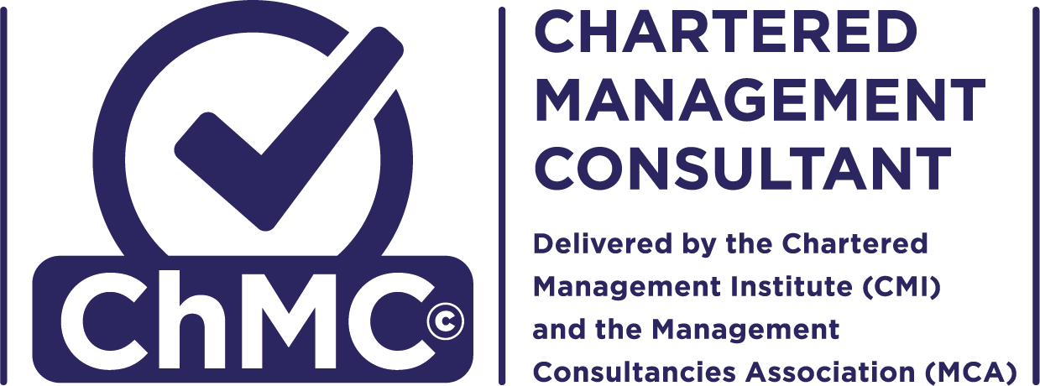

CHARTERED MANAGEMENT CONSULTANT (ChMC)
Continuous Professional Development Record

ChMC Contact Information
Name |  | Job Title
Email |  | Employer
Telephone

1 | CASE FOR MAINTAINING CHARTERED STATUS
Please reflect on your professional development from the last 12 months, and identify a minimum of 2 activities you have undertaken which link to the high level ChMC competencies shown in section 2. Maximum word count for the description of the activities is 1250 words in total.
For each activity you should consider:
- How it enhances your practice as a Management Consultant?
- How have you shared/plan to share the learning with others?

CONTINUOUS PROFESSIONAL DEVELOPMENT
For each activity identified in section 1 above, please indicate the main ChMC competency that it supports in column 1.
In column 2, please indicate those ChMC competencies you are planning to develop further in the next 12 months, with a brief description of your planned activity.
Please note you do not have to complete all boxes, the quality of CPD is more important than quantity.
ChMC Competencies | - Last 12 months | - Next 12 months
Values, Ethics, Behaviour
Leading Self
Leading Others
Leading and Managing Through Change
Industry or Sector Specialism
Clients & Markets
Strategy, Analysis and Context
Operational Delivery
Stakeholder and Relationship Development
Personal & Professional Development

3 | COMMITMENT TO CONTINUOUS PROFESSIONAL DEVELOPMENT
I commit to uphold my continuous professional development as a Chartered Management Consultant.
Signed:
Dated:

